CloudSonify: Harmonizing Spotify Insights with AWS

Abstract:

CloudSonify: Harmonizing Spotify Insights with AWS is a data engineering project focused on analyzing Spotify data using Amazon Web Services (AWS). Leveraging AWS services such as S3, Glue, Athena, and Quick Sight, the project extracts, transforms, queries, and visualizes Spotify data to derive valuable insights into user preferences and trends. By combining cloud computing with music analytics, this project offers a comprehensive understanding of Spotify user behavior and industry trends, serving as a valuable resource for data professionals and enthusiasts alike.

Introduction:

This documentation outlines the process and architecture of a data engineering project focused on analyzing Spotify data leveraging AWS services. The project involves extracting data from Spotify, storing it in Amazon S3, transforming it with AWS Glue, querying it with Amazon Athena, and visualizing insights using Amazon Quick Sight.

Architecture:

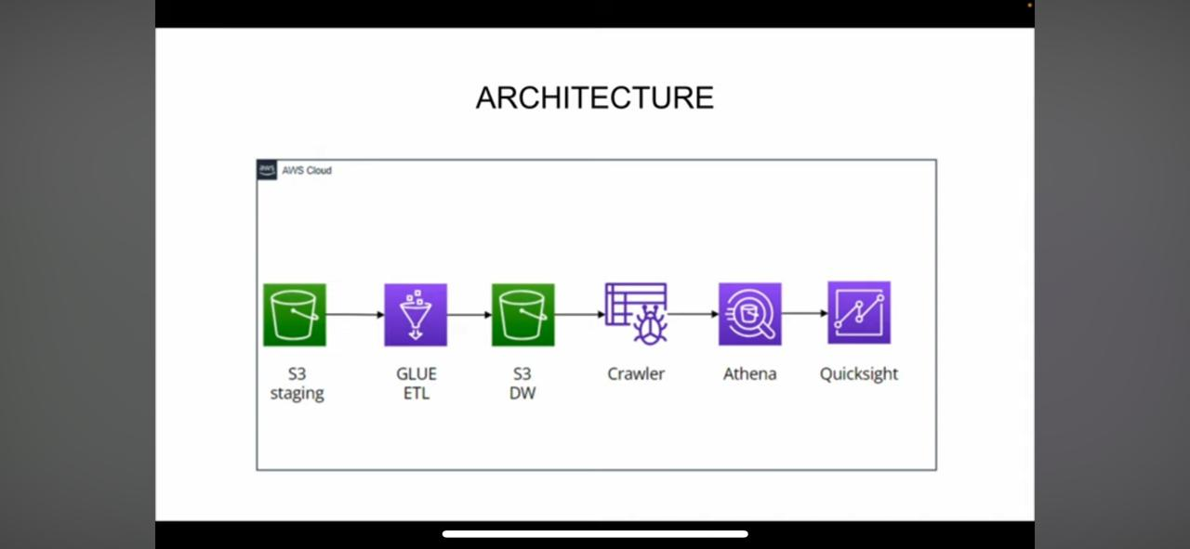

1. Data Extraction:

- Utilize Spotify API to fetch data including user playlists, track information, and listening history.

- Store raw data in Amazon S3 for further processing.

2. Data Transformation:

- AWS Glue is employed for data transformation tasks.

- Glue crawlers are configured to discover the schema of the data stored in S3.

- Glue ETL jobs are created to clean, enrich, and transform the raw data into a structured format suitable for analysis.

3. Data Storage:

- Raw and transformed data is stored in Amazon S3 buckets.

- Utilize S3’s durability, scalability, and accessibility for efficient data storage.

4. Data Querying:

- Amazon Athena is utilized for querying the structured data stored in S3.

- SQL queries are executed to perform ad-hoc analysis and retrieve insights from the data.

5. Data Visualization:

- Amazon QuickSight is used for data visualization and dashboard creation.

- Connect QuickSight to Athena to visualize query results and create interactive dashboards.

- Visualizations include charts, graphs, and tables to represent key metrics and trends in the Spotify data.

Steps

1. Data Acquisition:

The project commences with the acquisition of essential Spotify data sourced from Kaggle. This dataset comprises intricate details pertaining to tracks, albums, and artists, forming the foundational bedrock for subsequent analytical endeavors.

2. IAM Setup:

A crucial aspect of the project involves the establishment of IAM users and roles within the AWS ecosystem. A meticulous approach is adopted to create an IAM user endowed with comprehensive access to pivotal AWS services such as S3, Glue, Athena, and QuickSight. Additionally, a role is meticulously configured, granting full S3 access alongside relevant AWS service roles.

3. S3 Bucket Configuration:

With IAM setup completed, the focus shifts towards configuring S3 buckets, which serve as the primary repository for organizing and storing Spotify data. Through meticulous configuration, two distinct folders are established within the S3 bucket, facilitating the systematic categorization of data. Subsequently, the Spotify data files, inclusive of tracks, albums, and artists, are seamlessly uploaded to their respective folders within the S3 bucket.

4. ETL Job Creation:

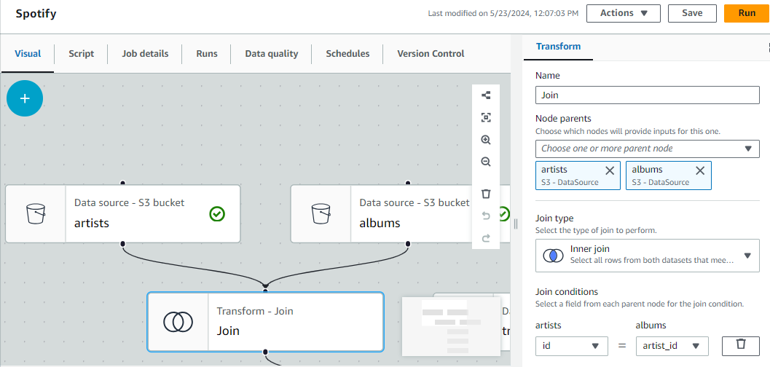

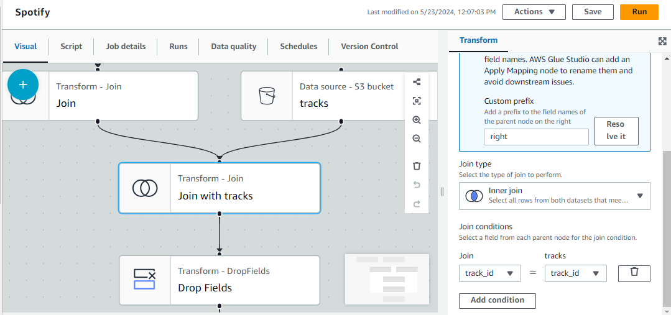

Leveraging the robust capabilities of AWS Glue, the project proceeds with the creation of Extract, Transform, Load (ETL) jobs. Employing Glue's intuitive visual ETL capabilities, a comprehensive job is meticulously crafted to harmoniously amalgamate data sourced from the three distinct S3 source buckets. This intricate process entails the application of specific conditions, including the seamless merging of data based on pre-defined criteria, coupled with the elimination of redundant fields. The resultant transformed data is judiciously stored within a designated destination folder within the S3 bucket, meticulously formatted in Parquet, thereby ensuring optimal efficiency in both data storage and processing.

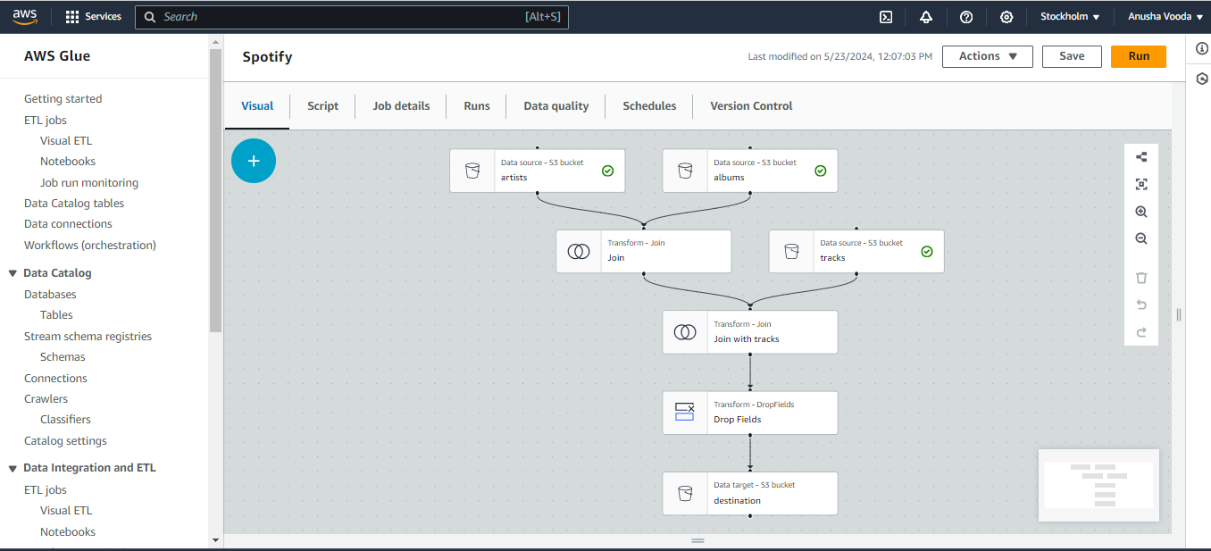

5. Crawler Configuration:

In a bid to automate the process of schema discovery for data stored within S3, a pivotal Glue crawler is meticulously configured. Tasked with crawling the designated S3 folder housing the transformed data, this crawler diligently generates a metadata catalog, thereby laying the foundation for streamlined data querying and analysis.

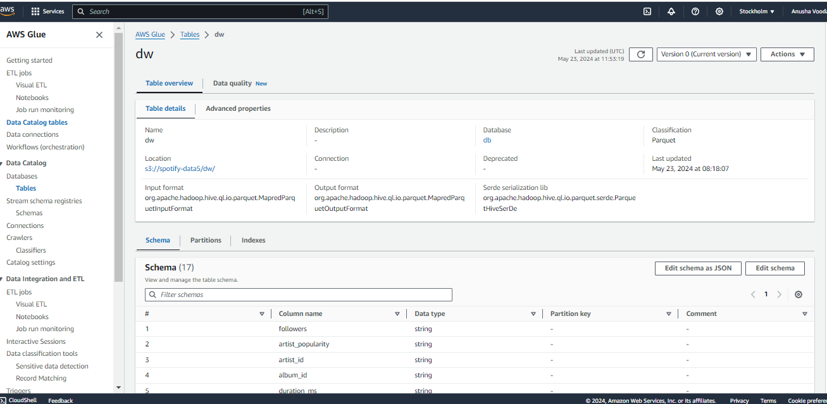

6. Data Querying:

Harnessing the potent capabilities of Amazon Athena, the project seamlessly transitions towards the querying phase. Leveraging the meticulously crafted metadata catalog generated by the Glue crawler, an array of intricate SQL queries are meticulously executed, meticulously extracting invaluable insights and metrics from the Spotify dataset. These queries serve as the cornerstone for informed decision-making, offering a nuanced understanding of user behaviors and preferences.

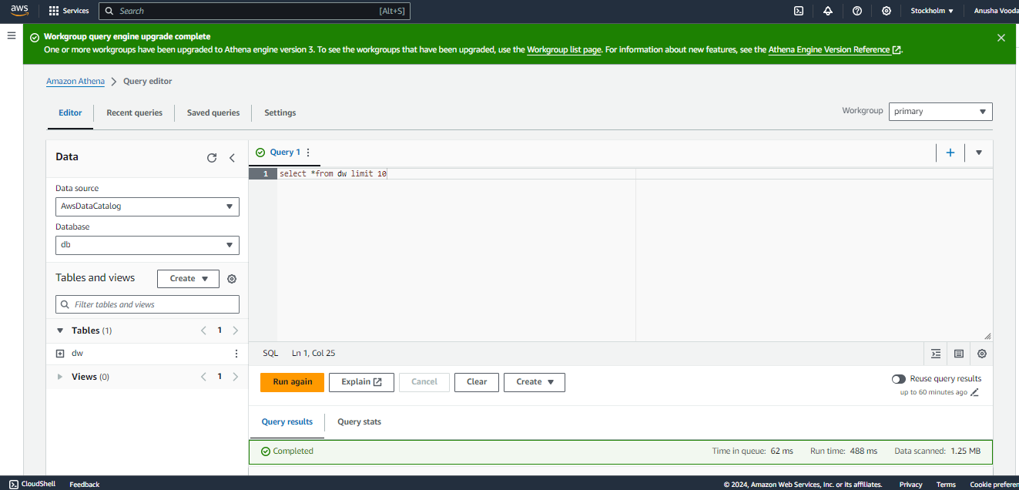

Query Results:

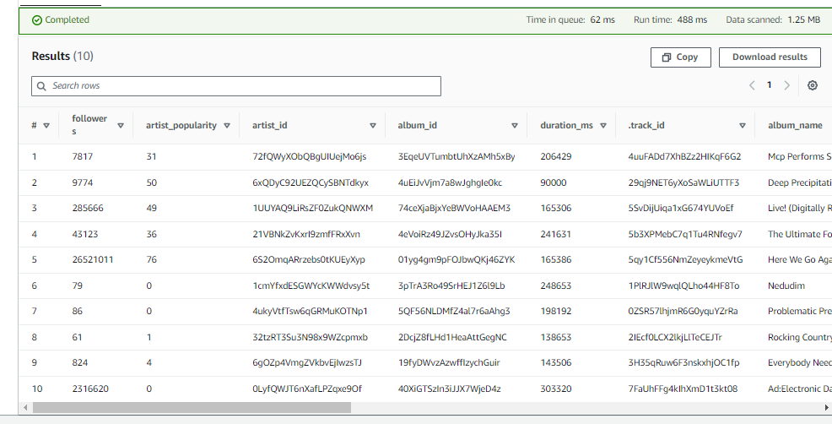

7. Data Visualization:

The narrative culminates with the leveraging of Amazon QuickSight as the quintessential visualization tool. Empowered with the capacity to craft interactive dashboards and visualizations, QuickSight emerges as the ideal conduit for presenting an array of key metrics, trends, and patterns gleaned from the Spotify dataset. Through visually immersive presentations, stakeholders gain unparalleled insights, thereby fostering a deeper comprehension of user preferences and overarching trends.

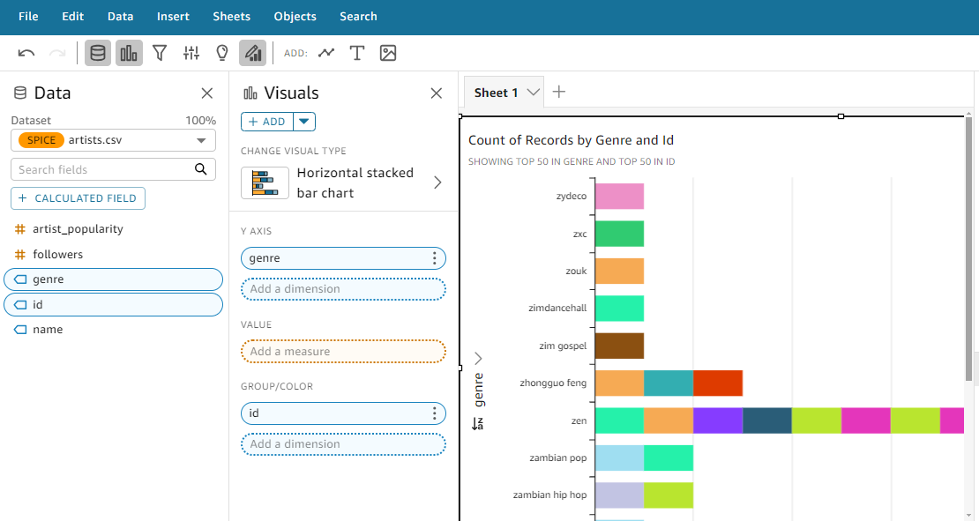

Conclusion:

This AWS cloud project exemplifies the seamless integration of AWS services to analyze Spotify data, showcasing the capabilities of AWS in handling data processing, storage, querying, and visualization tasks. By following the outlined steps and utilizing the power of AWS cloud services, users can efficiently analyze Spotify data and derive actionable insights to enhance user experiences and drive business decisions.

Datasets Links:

<https://shorturl.at/qBUX5>

Processed data:

<https://shorturl.at/biQUX>